# Week 4 Assignment: One-Way ANOVA

By: Zach Adair

Regis University

MSDS 660: Statistical Methods and Experimental Design

## Introduction

In this week’s assignment we are going to be performing a one-way ANOVA on three different treatments of pain relief that were tracked. Each patient is designed to take pain relief when they are feeling pain and to track the amount of time in minutes it takes for pain to ease. I will start by constructing a hypothesis for the three treatments and then perform a one-way ANOVA on the three treatments to conclude if my hypothesis holds true or not.

## Formulate the Hypothesis

Null Hypothesis: The mean is the same for all three groups.

Alternative Hypothesis: The mean is not the same for all the groups.

## Commands from working through a One-way ANOVA

While going through my commands I will articulate what my results are for each command as well as the results of the test along with the results of what to do with my hypothesis at the end of the testing. I will also do some additional testing at the end of my one-way ANOVA, a post hoc test and plot my data to help confirm the results of the ANOVA test.

First thing I need to do is load the data into RStudio:

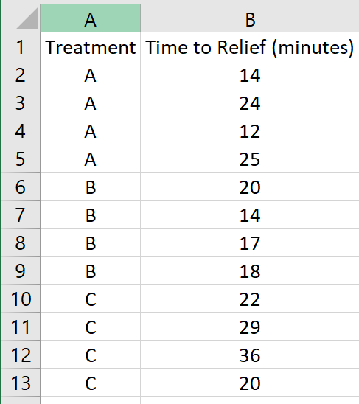

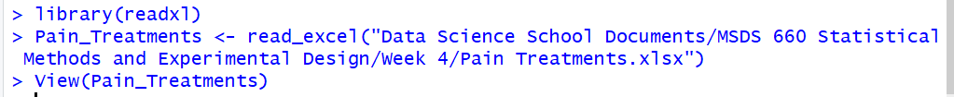

Once loaded I attached my data and took a look at the names of my columns in RStudio.

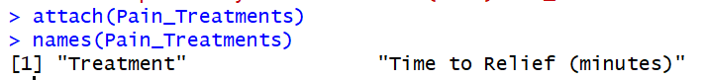

Now I need to set up each of my 3 treatment groups A, B, and C as factors. And then grouping by the different treatments.

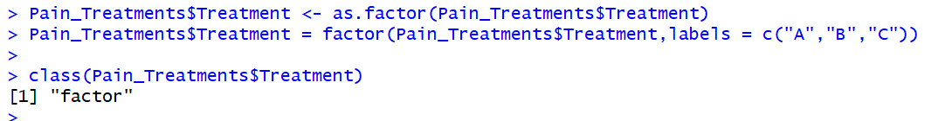

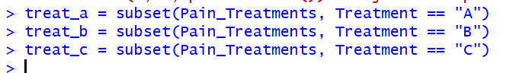

I know I don’t have many data points for each treatment but the next thing to do would be to plot the points on a QQ plot.

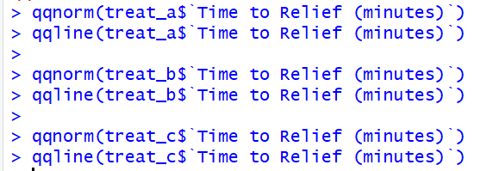

**Treatment A**

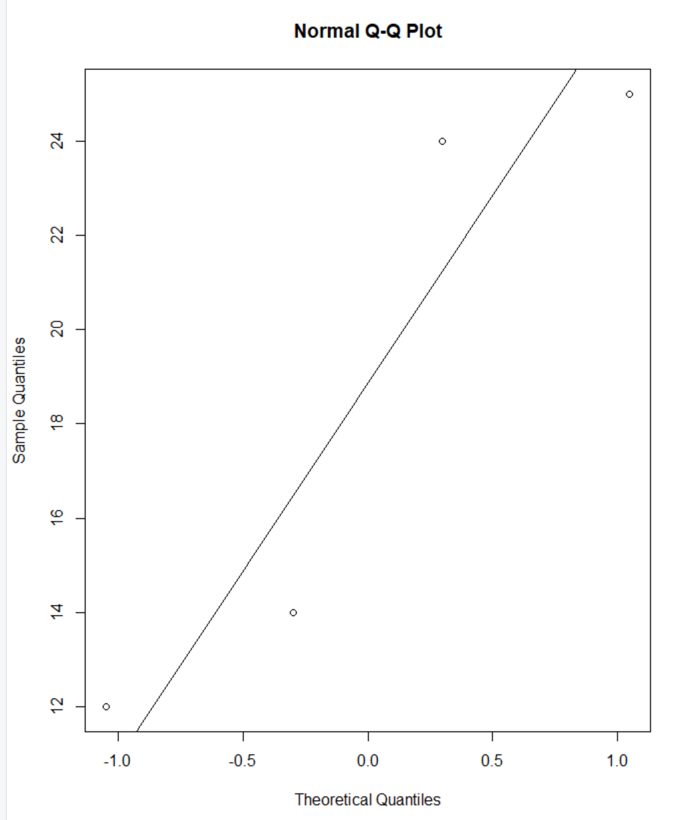

**Treatment B**

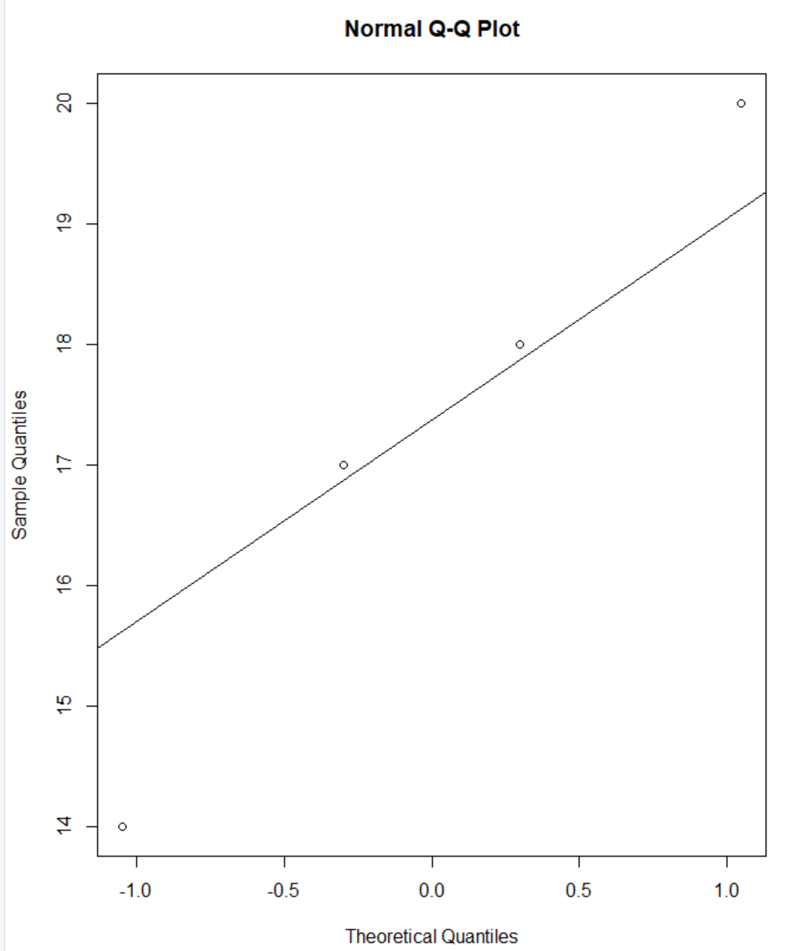

**Treatment C**

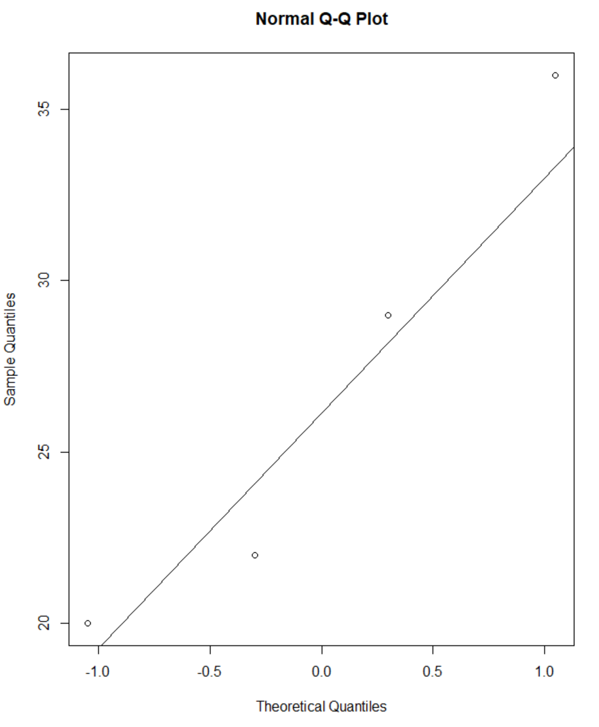

Running these tests of normality on our data is important because it ensures our data is normal, and if it was not we would not be able to run a one-way ANOVA test on non-normal data. Another requirement for one way ANOVA tests that you need deals with the variances, and that is that the variances must be homogeneous. To do this I will run a Bartlett test, ideally we want our p-value to be higher than 0.05.

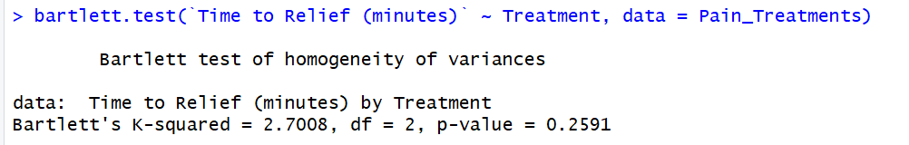

From our results of the Bartlett test we can conclude our variances are homogeneous because the p-value came back at 0.2591 which is higher than 0.05.

Now it is time to run an ANOVA model.

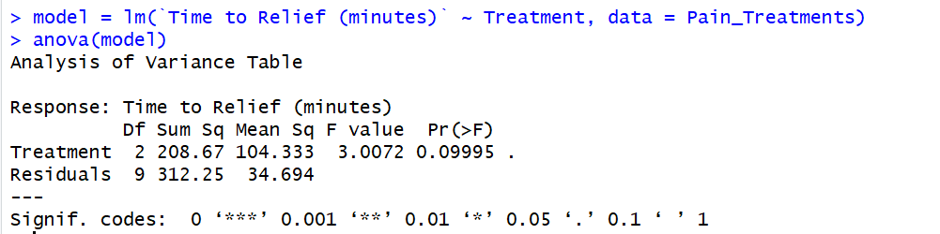

Our results would have us conclude based on the F value being at 3.0072 and our p-value being at 0.09995 and thus greater than 0.05 we can conclude that our null hypothesis is correct and that all means for each treatment are equal.

We can run a post hoc test after running our ANOVA, the one I’m going to run is Tukey’s HSD test.

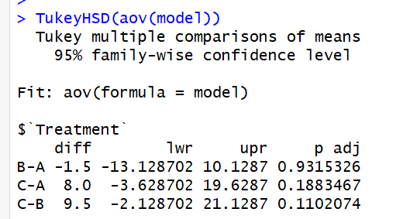

From the result we see each treatment compared against one another. What is important here is again the p-value. For all three comparisons our p-value is over 0.05 and thus we can conclude that the lengths are equal.

Finally I will create visualization of the data, for this data I will create a boxplot.

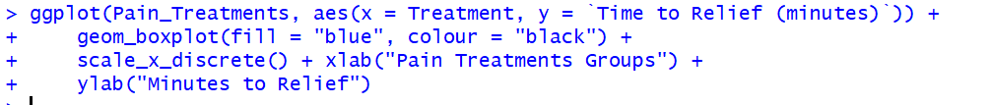

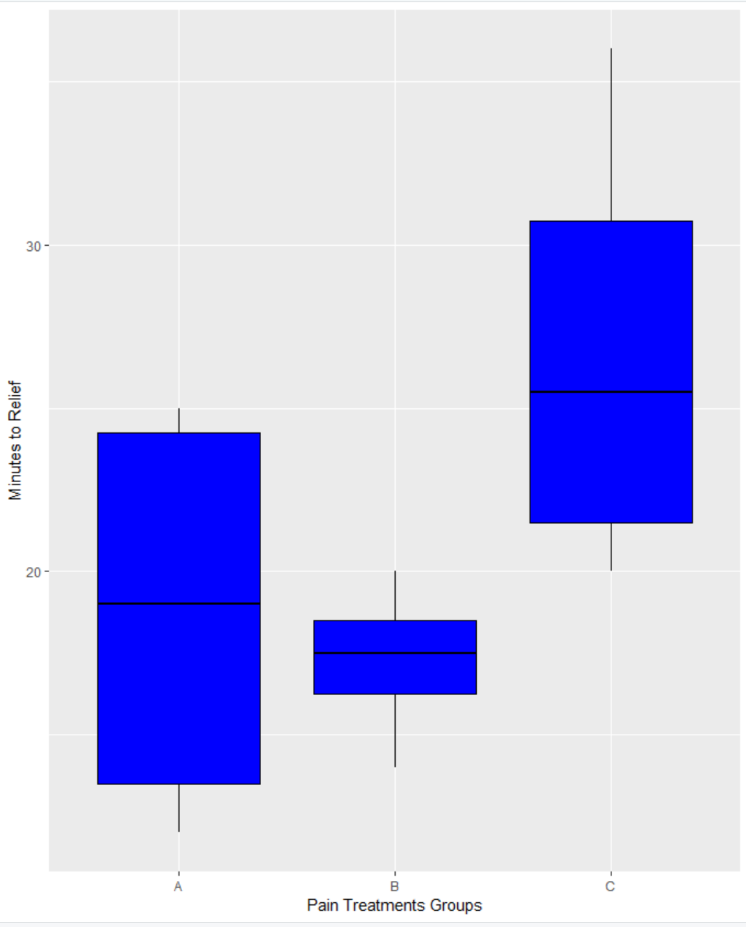

From out plot it would appear there is a difference between group C compared to group A and B but according to our tests run it would appear that our lengths are indeed equal and we would still accept our null hypothesis.

## Concerns going Forward

The only concern I really have going forward is the staunch difference in my graph makes my confidence in my ANOVA test less confident, but when I run through the ANOVA process again to reassure myself I find myself coming up with the same result. So what I can conclude is that the variances are relatively equal according to the one-way ANOVA test for the pain treatment results that I tested.

## Summary

In this assignment I learned a lot about one-way ANOVA and using it to test multiple groups in RStudio. I learned about how useful the tests are to make sure an ANOVA test is right for the data I have and then I gained a better understanding of how to read the results. The RStudio commands were straightforward as well making it a simple analysis to carryout from start to finish.